

**Marketing Plan Fall 2022 By Brendan, Nelson, and Jim**

**Executive Summary**

BUTTER is a bespoke bakery business that produces semi-customizable snacks that come in uniquely designed packaging. BUTTER charges a higher price than the industry average because, unlike industry-made foods, BUTTER’s products are completely hand-made from scratch using specialty, high-quality ingredients and baking techniques that differentiate them from commercial bakery products. Besides this, the comparative competitive advantages of BUTTER could be the short time frame needed to make products, the ease of obtaining the ingredients needed to fulfill orders, as well as the option of home delivery or pickup.

From a promotion and advertisement aspect BUTTER is aiming to appeal to a niche marketing share where prospective customers would appreciate the unique recipes and bakery methods used by Karen-Joy that overlook the slightly higher price point. BUTTER will focus on advertising its products primarily through local newspapers, social media, a strong website, and flyers. In addition to traditional promotion and advertising like newspapers and flyers, BUTTER would also make an effort to attract the younger generation by being more active on social media, for instance, BUTTER could create a business page on Instagram, Twitter, and Facebook to reach out to potential customers on those respective platforms. Perhaps, offering a festival or seasonal discount, and participating in homemade-based food fairs in the neighborhood would essentially increase the exposure of BUTTER to the public.

The after-sales service of BUTTER includes a guarantee, delivery, and customer satisfaction survey. After a purchase, BUTTER will ask the purchaser to fill out a short survey to determine if the end products and service meet their requirements and meet the requirements of production as indicated in the section above. Butter values customers not only depending on how much purchase they made but every single customer which customer would automatically receive an email or text message asking them to rate the quality of service, actual product, and timeliness of delivery from a scale of one to ten respectively as feedback comes along with room for improvement and perfection.

# COMPANY DESCRIPTION

## Business Background

Karen Joy is a health-conscious business owner who has experienced being a vegetarian since the age of 15. She consistently strives to work with the most authentic ingredients for her customer’s taste, a foundation of her business close to her since she cooks for herself almost every meal. She has been observing how establishments that tout healthy food serve inadequate meals with low-quality ingredients. After contemplating the ingredients and methods that contribute to exceptional food, Karen Joy concluded that homemade goods are the best for consumption. BUTTER is Karen Joy’s avenue into the cottage foods business, allowing her to create delicious, high-quality, bespoke baked foods and sell them to Michiganders.

## Company leadership & Organizational Chart

BUTTER is a business owned and operated by Karen Joy. This simplified management structure of BUTTER is what allows her to respond to market change more efficiently than if she works with others in the business. She has entire control over taking orders, production, and delivery.

## Mission

The mission of BUTTER is to create delicious baked goods by emphasizing high-quality ingredients and refined techniques that inspire each bake with a thoughtful and creative process

## Product/Service Description

BUTTER is a “Bespoke” home bakeshop - an establishment where flour-based foods are baked in an oven and sold to consumers. BUTTER is a cottage business because it aims at producing baked goods from a home kitchen for prospective customers. High-quality and simple ingredients along with refined baking techniques are what define this business and result in high-customer involvement and satisfaction.

## Need For This Marketing Plan

This marketing plan is created as a guide to help us identify and fulfill the needs of Karen’s customers. BUTTER is a “Bespoke” brand, meaning that each product is uniquely tailored to its customer. It's only right that the marketing plan aids BUTTER in connecting its bespoke recipes to the right target market.

## Purpose Of This Marketing Plan

The purpose of this plan is similar to the need for a marketing plan with a few additional key reasons. Using this marketing plan BUTTER can identify its target audience both at a macro and micro level, thus tailoring the business and its recipes to its customers. BUTTER can also

use this plan to understand trends, market growth opportunities, areas to improve, and areas of success. Using this information BUTTER will be able to develop a solid marketing strategy that will ensure that it meets the needs and wants of its customers.

# COMPETITIVE ANALYSIS

## Market Summary

In Michigan, there is a high employment level for bakeries according to the Bureau of Labor Statistics as of May 2021. Specifically, there are around 6,650 bakers employed in the state of Michigan. In addition, Michigan boasts a high location quotient of 1.27. A location quotient greater than 1 indicates an industry with a greater share of the local area employment than is the case nationwide. In other words, Michigan has a high volume of bakeries and bakeshops throughout the state in comparison to the other U.S. States, implying significant competition for BUTTER. Having said that, competition for cottage bakeries is far less. Often with only a single cottage bakery being operated within a large city or multiple towns. There is good potential for the cottage industry in Michigan, especially in southern Michigan where Karen Joy is located.

## Market Demographics

Gender, ethnicity, marital status, education level, and occupation don’t play as strong a role in determining the potential customers of baked goods. It is, however, imperative to examine the potential consequences of age and income level in Michigan and their effects on BUTTER. In Michigan, the median household income was $63,498 in 2021 according to American Community Survey data, which is slightly lower than the U.S. median household income of

$69,717. In 2021, the poverty rate of Michigan was 13.1 percent, a number slightly higher than the national average of 11.6 percent. This distinction is important because BUTTER focuses on products that are sold at a slightly higher price per ounce compared to standard grocery items because it uses higher quality and better-tasting ingredients. It isn’t a standard grocery product. The high price points of BUTTER’s products might be potentially cumbersome for the business, primarily due to these lower-income statistics. In Michigan, nearly half of the population are millennials or from Gen Z, an important demographic segment statistic discussed in the next section.

## Market Needs

A recent national study revealed that generation Gen Z (people born after 1997) prefers the consumption of desserts. However, BUTTER emphasizes slightly higher prices that reflect the exceptional quality of their goods. Thus, this type of business would also appeal to millennials, who according to recent research place a higher priority on health and wellness than any other generation. Desserts that taste delicious yet are made

with high-quality ingredients and refined baking methods can crossover and appeal to both generations. Roughly 44.6% of the Michigan population is a millennial or Gen Z (ages 10-44). Thus, there is a large target demographic for BUTTER due to the younger generations’ need for baked goods and desserts.

## Market Trends

According to the former U.S. Agriculture Secretary Tom Vilsack the local farmers' markets sales as well as cottage food sales have increased from 5 billion dollars in 2008 to a projected 20 billion dollars in 2019 (source [link](https://www.pewtrusts.org/en/research-and-analysis/blogs/stateline/2019/03/19/as-home-cooked-cottage-food-industry-grows-states-work-to-keep-up)). People want healthier food options that are locally grown and reasonably priced. The Covid-19 pandemic caused an increase in the number of people making their food themselves but also people who started cottage foods businesses to make money on the side and cater to the needs of their community in lockdown. Over the past five years, laws and restrictions regarding cottage foods have also lessened allowing more people to start their cottage food businesses. What the pandemic did for this industry was that it brought about an awareness of home cooking and an appreciation for it.

This Google Trends graph shows the steady increase in interest in butter in America over the past nearly two decades. As we can see the trend is a positive trend with the trend line gradually increasing each year. The trend looks identical for Michigan (graph below). The ridges/high points correlate to the times of the year when people show the most interest in the ingredient. We can see an increase in December of each year. This proves that there is a trend of using or buying butter for the Christmas and New Year holidays.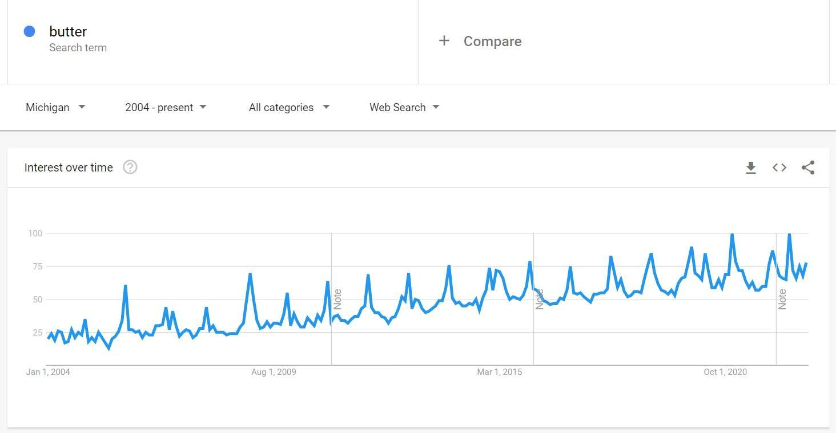

## Market Growth

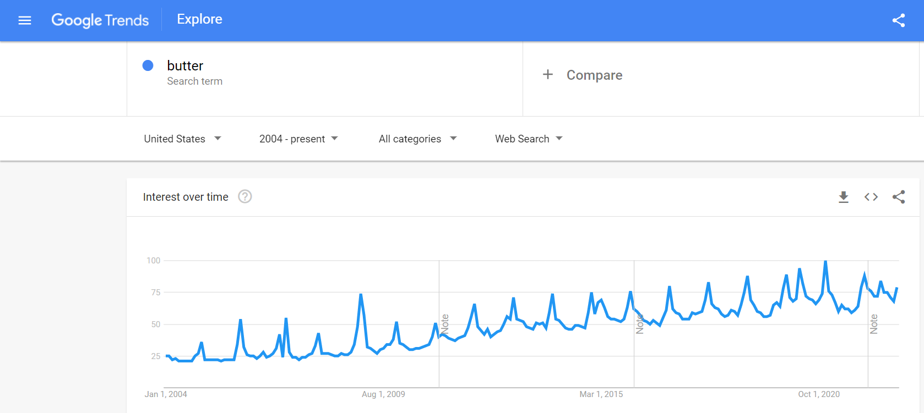

There is great potential for growth in the cottage food industry, just this year the Michigan House raised the income cap for the industry from $25,000 per year to $45,000. Michigan has also allowed mail, internet, and third-party delivery of sales after the customer has been given the chance to directly interact with the business operator before the purchase is made.

## SWOT Analysis

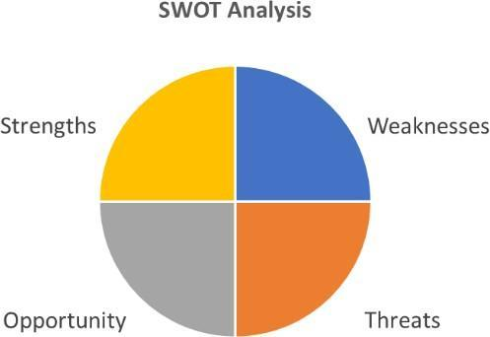

| **Strengths** | **Weaknesses** |
| --- | --- |
| * The menu is customizable and the baker knows how to make customized orders well. * The butter is rich, it’s what makes the product one of a kind, tastier, and unique. * A variety of homemade pastry options to choose from rather than just macaroons, cookies, and cakes. * Home drop-off or pickup options. * Cheaper than local competitors * A good website that is more intuitive and well-designed | * No traditional desserts on the menu such as cakes, cupcakes, or muffins. * BUTTER is not listed on Google's list of homemade desserts near me. * Doesn’t have a separate Instagram page for BUTTER, it comes under Handsewn. This might make the business harder to find on a generic search on Instagram. * Needs a Facebook page to reach the older generation who use FB only. |
| **Opportunities** | **Threats** |
| - Very few competitors around Benton Harbor. | - Small established bakeries in the area with variety and a customer base. |

| * Expand social media presence. * Improve BUTTER’s website. * Get a commercial kitchen license to be able to deliver products and sell more. | * Getting people to choose a less healthy option than other low-fat recipes offered by BUTTER’s competitors. * Products won’t appeal to people who are lactose intolerant. * Low prices for products yield lower profit margins. |
| --- | --- |

**Competition**

Taking consideration the scale of the BUTTER business it appears to be a startup business therefore its main competitors around the territory in Benton harbor would be a bit of swiss pastry shop located in Stevensville that is about 15 mins driving distance from Karen joy’s Butter business a marked on the google map below where they serve Artisan Bread, Croissants, Danish, Specialty Cakes, Tortes as well as Pastries with relatively high customer satisfaction reflected on the reviews. Another primary competitor being considered is a forte cafe located at 138 Water St Benton Harbor, MI 49022 shown as No. 8 on the map where they have pastries products from scratching, homemade butter, and vanilla to offer the tastiest pastries in a healthy and transparent making method that was rated 4.5 out of 5 by 20 multiples customer. Those are all local proprietorship business that maintains a small size similar to BUTTER while aiming to serve the local community as well as a visitor that has become loyal customers to them and already acquired a certain proportion of the bakery market hence BUTTER would have succeeded if we thoroughly target its buyer persona to either attract new customer by developing niche market that provides end product beyond its current competitor.

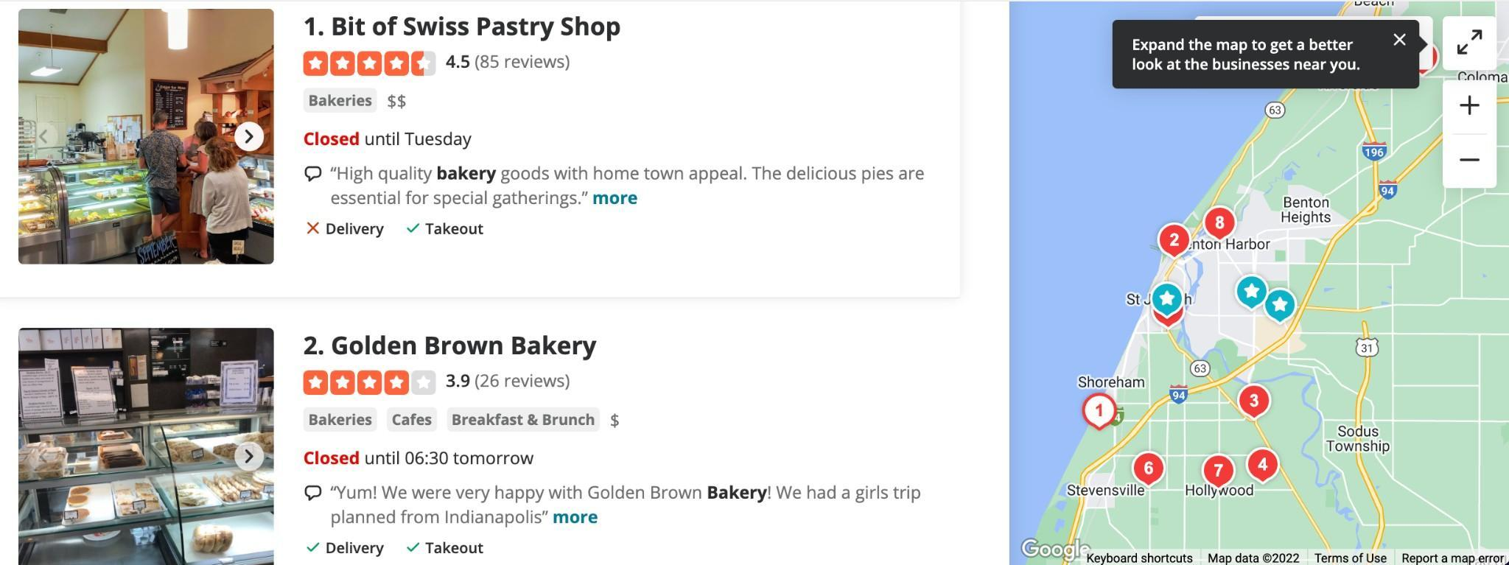

## Product Offering

In terms of product offering BUTTER products will be sold to customers in a delicate card folding box with a ventilation hole to ensure the baked foods would last longer and stay crispy at room temperature and the aroma of BUTTER would spread in the air. Each box will have nine pieces of shortbread in it weighing approximately 12 grams per each, BUTTER measures roughly 3 inches in length and 1.5 inches in width.

Ingredients that have been used in all products as well as nutrition and calories indicator will be specified on the packaging. Karen Joy would be delivered BUTTER products to customers in person or for those who ordered online customers could pick it up where it was baked when the order was done.

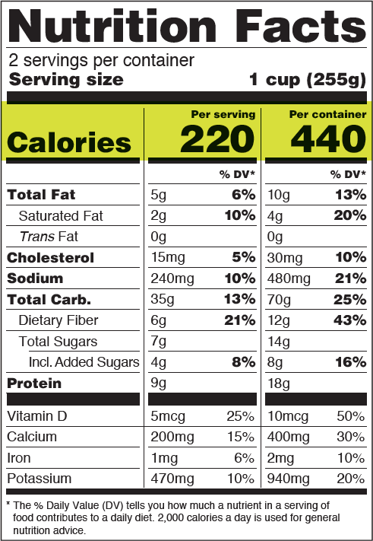

## Keys to Success

| Exposure: | Customizability: | Innovation: |
| --- | --- | --- |
| The population in Benton Harbor is recorded at 9806 on Google which has the potential to grow as health-conscious customers might be more dependent on BUTTER. | By creating variations in options of ingredients, customers get to choose what their BUTTER is made of. The demand for BUTTER would soar as customers' unique requests could be satisfied. | Plenty of pastry options are available to customers whether it is macaroon, cookie, or cake in the menu with various flavors, topping, cream, flour, or even shape to best-fit customers’ needs flexibly. |
| Preferably Karen Joy could exhibit BUTTER bakery samples when the food fair is in town to increase the publicity and awareness of customers. | Striving to serve customers with the best quality possible since inception as Karen Joy has said the goal is to focus on quality, not quantity. | The idea was retrieved from Judaism bakery culture where they make Cookies similar to how BUTTER is made to differentiate from traditional bakery or pastries. |
| Sooner or later BUTTER would become renowned as the Facebook pages as well as a separate website domain has been established to reach out to a larger group of prospective customers of different ages. | CRMs are emphasized in this business model as retained customers are the majority group of customers that shows dependence on BUTTER as a result owners receive positive feedback from them. Good BUTTER sells itself | BUTTER business is regarded as a make-to-order operational mechanism that avoids unsold BUTTER being wasted and dumped, meanwhile increasing the flexibility of pickup orders as customers could choose when to pick up or deliver to their place without waiting in store. |

**Critical Issues**

### Geographical regulatory restriction:

As the bakery location belongs to Michigan states and due to safety regulations of Michigan technically Karen Joy cannot sell her BUTTER anywhere else outside Michigan which would be considered breaking the laws and that significantly limit the potential customer as the shipping of the order required herself throughout the delivery and customers are less likely pick up their order if they live remote. Benton harbor, Saint Joseph, Stevensville, and Berrien Springs are preferable ranges of target customers as geographically closer to where BUTTER is baked.

### Distributions

As all the orders are currently through phone calls from repeated customers or online ordering that the business might encounter challenges especially when it comes to tourists during the summer vacation period if Karen Joy could possibly rent a store where she can sell and bake BUTTER her business would go virtual as the customer would be more likely to purchase those BUTTER that they would get to see the actual BUTTER and how does it make in the bakery store.

### Multi-tasking

As Karen Joy has mentioned in the intro that she is managing three businesses across health therapy, bakery, and garment that are going on simultaneously and she would be fully responsible for all those businesses from raw material acquisition, operation, customer service, selling and marketing promotion done by her. It would have been even harder for her to maintain three businesses open to customers while not hiring additional employees to be in charge of a certain segment or process as spending extra time on a business is a sacrifice of another business that deserves less energy and time. If she wanted to be more productive in a specific business she would need to either hire labor or narrow down the businesses she is providing.

CONSUMER ANALYSIS

## Target Markets Description

The target market for BUTTER is Gen Zs and Millennials, these are individuals aged from 10 to 44 years old. Having said that, we do understand that the majority of buyers (the people who are going to actually purchase BUTTER products) will probably be aged around 25 - 44 years old. We are targeting products to the working class, people who are looking to take a break from their regular cookie and snack options to try BUTTER’s foods that have a rich taste, use high-quality ingredients, and are flavorful. These are the main points we are going to focus on when selling BUTTER products.

## BUTTER Buyer Persona

The two buyer personas below talk about Raj and Jessica. Raj is a DevOps engineer and Jessica is a graphic designer which is both high-income jobs. Both are also around the same age and need good-tasting, quality snacks to purchase. This is where BUTTER comes in. These buyers are looking for something that you can’t find on a supermarket shelf, something different with an emphasis on taste rather than health.

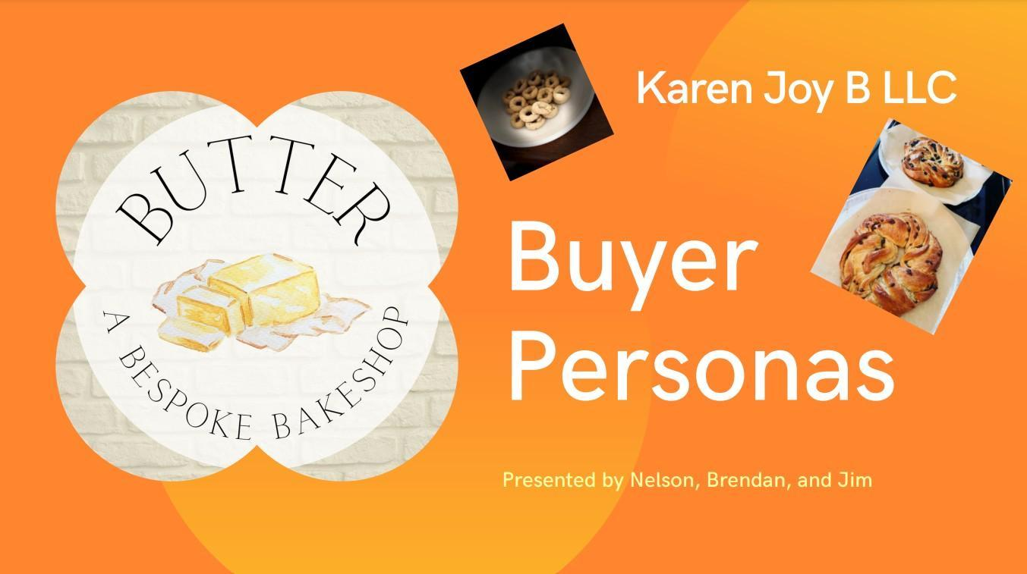

Persona 1:

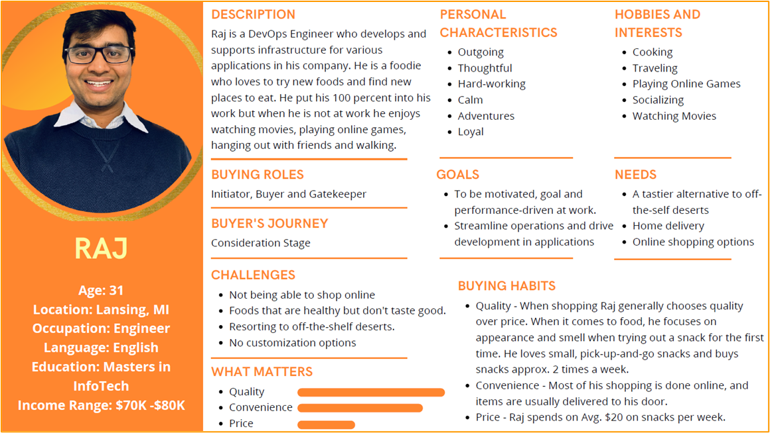

Persona 2:

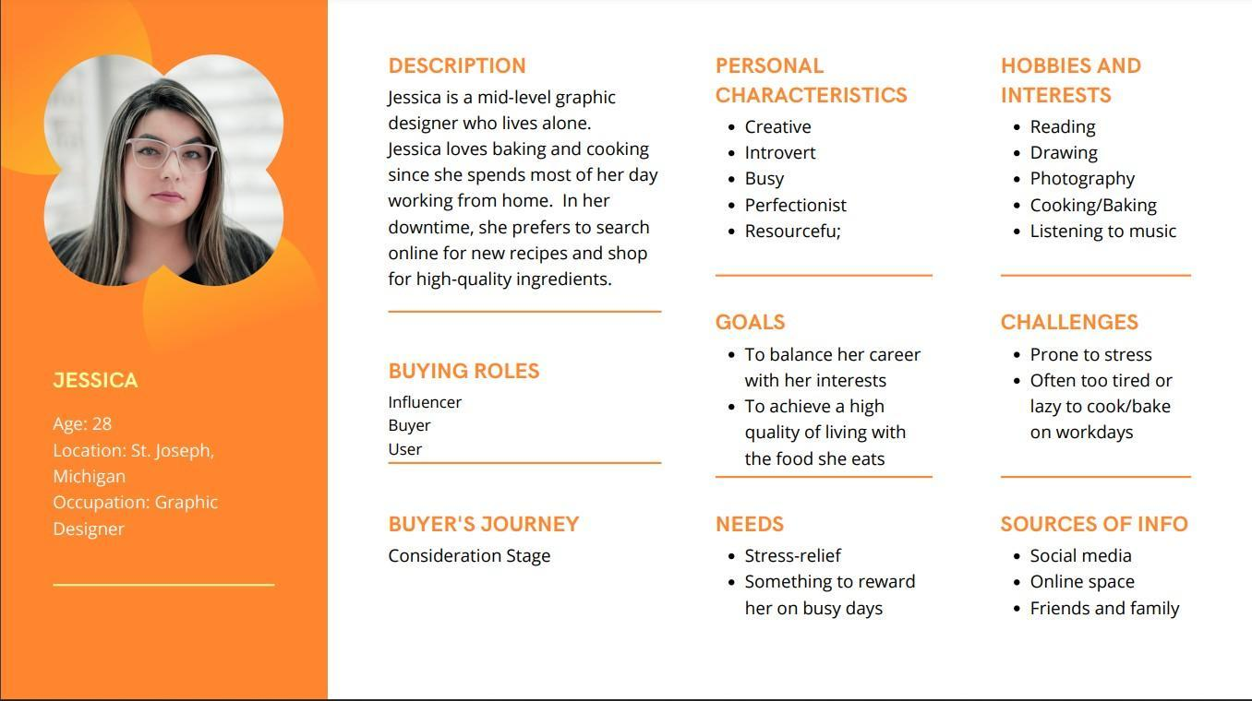

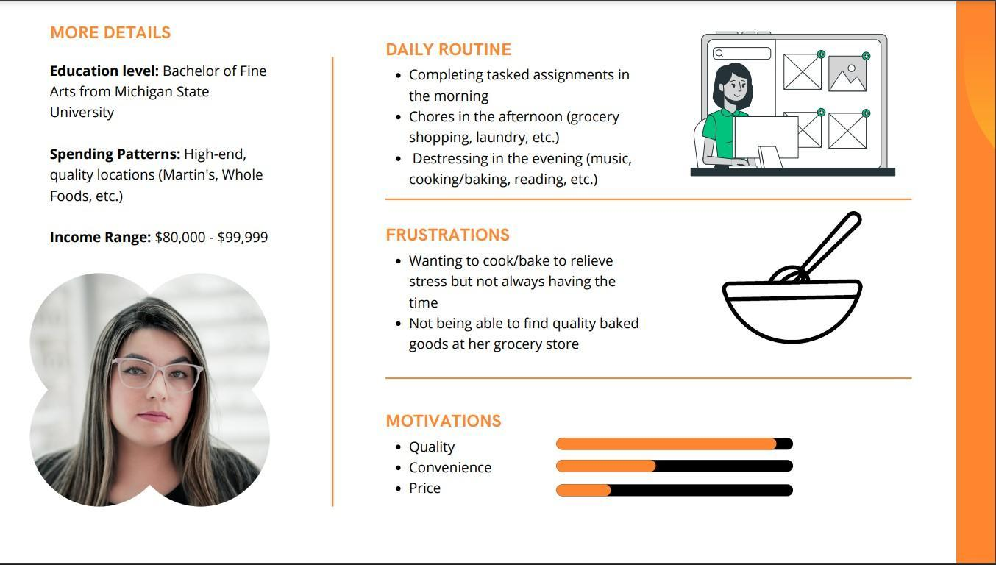

## Positioning

1. Product attributes and benefits: BUTTER contains nutritions and elements that are essential to human beings, for instance, iron, fiber, protein, fat, and vitamins that contribute to our well-being fundamentally considering BUTTER comes with a variety of flavors for customers to choose from.
2. Product price: The pricing for BUTTER would be around $9 for a box of nine pieces of BUTTER that includes packaging, wrapping, and a guarantee, for delivery service customers will be charged depending on their delivery location accordingly. The price range is affordable to most of the customer and pastries enthusiasts, therefore, they would have exposure to Judaism homemade BUTTER.
3. Product use and application: BUTTER could be used as a gift for birthday parties, friends, or family members to express the joyfulness of having pastries that are genuinely made out of sample ingredients but with a decent aroma and amazing taste. Everyone loves desserts and by sharing BUTTER with others it signifies the importance of a relationship being together with family and friends.

## Market Research

The bar chart below illustrates the anticipated potential growth of the bakery market that would have been achieved by assessing its customer trends, pastries market sales, and performance, global customers' preference for bakery and pastries products as well as the financial report summary from those companies or businesses involved in the bakery and pastries industry. From 2015 the size of cookies was 6.3 billion and 6.6 billion the following year. By visualizing the bar chart we have observed that there is a gradual and steady increase in the global cookie market that slightly increases year by year from 2015 and until 2025 cookie industry size will peak at around 10 billion with a 5.3% growth rate from 2019 to 2025.

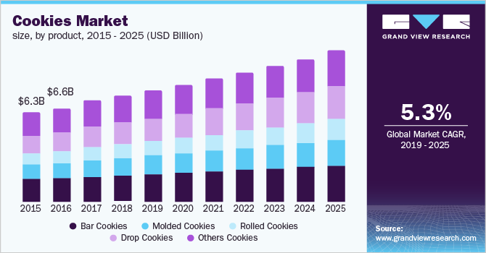

However, geographically if we classify the cookie market by region we come to realize that in Asia pacific cookie market is experiencing the fastest growth rate that is recorded at a 6.8% annual rate from 2019 to the present with the momentum of continuous growing trend projected in the future years while North America and Europe still the dominant market share for Cookie industry. Even though the resource is considerably generic for BUTTER business yet to some extent it has shown the rise of potential marketing in Asia pacific where the growth is substantial and where those cookie sales have been made mostly.

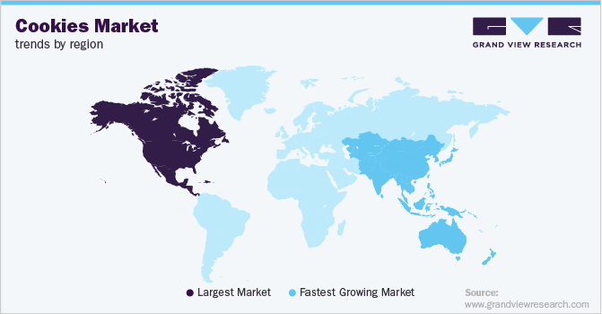

# Marketing Objectives

**Our goal: To plan for your product, your brand, and related services**

# Product Strategy

## Product Description

BUTTER is a “Bespoke” home bakeshop - an establishment where flour-based food is baked in an oven and sold to consumers. BUTTER is a product business because it aims at producing baked goods for prospective customers. High-quality and simple ingredients along with refined baking techniques are what define this business and result in high-customer involvement and satisfaction.

## Specialty Product

This business involves the production and selling of specialty products. Karen Joy’s baked goods are considered a specialty because they are hand-crafted with specific baking

methods/techniques and enhanced with quality ingredients - aspects that differentiate her desserts from common grocery baked goods. This has significant consequences for this marketing plan. Her higher price point reflects her specialty baked goods and we need to decide whether we want her to navigate toward a higher price point to reflect the uniqueness and quality of her baked goods or trend toward further differentiating her products to meet her customer’s expectations when they buy her high-priced goods.

## Product Lifestyle

With BUTTER, Karen Joy is currently in the market introduction stage in the product life cycle. She has recently launched her online website and has not yet established a solid customer base (as evidenced by her limited sales). The market introduction stage can be considered the most vital stage when it comes to building product awareness and reaching the target market - this is where this marketing plan comes in.

## Brand Awareness

The population in Benton Harbor is recorded at 9806 on Google. The community is smaller, but that does not have to be a negative aspect of building brand awareness. If BUTTER focuses on providing an excellent customer experience with its goods, BUTTER can blitz the market and become well-known to the local, tight-knit Benton community through

word-of-mouth marketing. Product giveaways at food fairs, discounts during the holiday season, and buzzworthy posts on social media can get Benton talking about the product, which can potentially spread to nearby towns.

## Packaging/Labeling

Karen Joy has already selected a package to use for her baked goods. The pricing for BUTTER would be around $27 for a box of nine pieces of BUTTER that includes packaging, wrapping, and warranty. Delivery service customers will be charged depending on their delivery location accordingly. As of now, the price range and design seem reasonable and attractive, thus we have no further concerns/suggestions regarding her choice of packaging.

## Wholesale Packaging

Karen Joy needs to secure a cost-effective wholesale packaging supplier that keeps her supply chain running smoothly. There needs to be a balance between cost-efficiency and quality packaging. The wholesale product packaging needs to accomplish the following:

* Complement the design of the product that’s inside it.
* Show off her branding
* Make the most of wholesale packaging pricing discount

Since BUTTER involves high-quality, luxurious products she might also want to consider other packaging supplies at wholesale prices. Tissue paper can add an extra level of both security and class to her [packaging kits](https://packhelp.com/bundles/). Wrapping her product in branded tissue paper or [packaging](https://packhelp.com/packing-paper/)

[paper](https://packhelp.com/packing-paper/) will leave a positive first impression on her customer's minds from the moment they open her package.

## Differentiation

The idea for BUTTER was retrieved from Judaism bakery culture. BUTTER is made to mimic this process, which differentiates this business from the goods sold in traditional bakeries and grocery stores. As stated above, BUTTER is focused on the production and selling of specialty products. However, Karen Joy also has another edge in that she includes plenty of pastry options available to customers including macaroons, cookies, or cakes on her menu, complemented with various flavors, toppings, creams, and shapes to flexibly fit her customer’s needs. Many specialty bakeries only focus on one type of baked good, such as cookies or cake, but BUTTER’s unique production methods/ingredients and the diverse menu will serve to separate her business from the pedestrian bakeries AND specialty bakeries at the same time.

# Distribution Strategy

In this section, we are looking at how BUTTER will distribute its products. The correct strategy will allow the customer to have freshly made ready-to-eat products that are full of flavor and fine ingredients. We are looking at how we are going to get BUTTER’s products from the place it was made to the end user. Since BUTTER already has an up-and-running website it is hitting the ground running. Websites are a great starting point in the product transaction process. BUTTER’s website allows customers to place orders online and choose between a local pickup or a local delivery. These are the best possible options as permitted by law for a cottage business. One possible option for the delivery option is to give customers delivery radius options and increase the price of delivery as needed. For example, 25 miles would be an additional delivery cost of $8, 30 miles would be $10 and 35 miles would be $12. This would increase the reach of the business. You could also include an extra product into the price as an incentive for pickup like Domino's Pizza does with their $3 coupon for pickup.

## Inventory

As this is a cottage business and a bakery business at that. The benefit of a cottage business is that generally, orders are smaller in size unlike with local bakeries and wholesale stores. The inventory of ingredients does not have to be stocked continuously but they do need to be obtained easily and at short notice.

## Production

BUTTER’s ability to produce the end product in just one day gives it a competitive advantage over its closest competitor (by location). Production is half the appeal of BUTTER, products are handmade and each product is unique, relying on the expertise and experience of Karen Joy. A commercial kitchen license isn’t necessary for the time being as BUTTER is aiming to

keep operations local for now, catering to the tastebuds of Michiganders. Looking at the trends of interest in butter and desserts there is a lot of potential for BUTTER in Michigan.

# Integrated Marketing Communication Strategy

## Promotional Objectives

With promotional objectives, BUTTER is looking at how to get customers' attention and ultimately buy BUTTER products. The first objective should be building awareness of the brand. A few methods of doing this could be advertising through local newspapers, creating business flyers, being present at food-related events, or even being more active on social media. The business card and the website are a great start but the issue with business cards is that it requires one to physically hand over their cards to potential customers. The next objective is creating an interest in what BUTTER has to offer. Things like offers, holiday deals or discounts could help with this. The third objective is to help the customer revisit the brand. This can be done with discounts, seasonal emails, customer reviews, and offers. [Click](https://www.youtube.com/watch?v=8tJS4O_tyCw&t=126s&ab_channel=SonuSingh-PPTwale) [here for more information](https://www.youtube.com/watch?v=8tJS4O_tyCw&t=126s&ab_channel=SonuSingh-PPTwale)

## Promotion and Advertising

Taglines: taglines are an effective method of getting a point across to an audience as usually taglines are memorable and catchy, thus they can be more easily associated with the business in the future. BUTTER's tagline is “A Bespoke Bakeshop”. It encompasses Butter’s main feature or offering to the customer, which is, a “bespoke” one-of-a-kind product(s). It’s a unique tagline in itself and it clearly helps the brand position itself in the eyes of the customer as a company that makes premium, quality products. That’s exactly what BUTTER needs.

Slogan (message further developed): There is an option to develop the tagline into a slogan. There is also the option to create slogans for each product that describes that food in a way that makes the product more appealing to the customer.

## Promotion Options

|  | Cost | Pros | Cons |
| --- | --- | --- | --- |
| Website | Initial cost: $180  - $200.  The maintenance cost per month is $40 -  $50. | It’s easy to create a business website. Fairly inexpensive. You can customize it in any way you like. Customers associate a business with a website as more legitimate and trustworthy. You have a chance of being on a search result on a topic associated with your business, i.e. “bakery” | Initial payment is required to buy a domain. Website security and customer data received over the website are now some things you have to protect/worry about. |
| Social Media | Initial cost: free.  Maintenance cost: varies. | It’s becoming easier to create content for your viewers. There are numerous platforms you can choose to post on that appeal to different age groups/audiences. Social media analytics tools allow you to instantly see trends in sales and interests for your business and other related businesses. It's free! | Social media followings can take a very long time to build and it takes skills and resources to maintain. Social media requires you to interact with the platform regularly. Security concerns with each platform can be a concern. |
| Business Cards | Cost: $30 for 500 business cards. | It’s more personal and it can help build customer relations. Tons of possible designs and card materials to choose from or create. Easy to display. Looks professional. Fairly inexpensive. | Design and printing cost. It will cost every time you want to update information on the cards. Limited information on the card. |

| Newspaper Ads | Estimate rate:  $25 - $30 for a column inch black and white space. | Builds trust between customers and the business. Has the ability to reach a lot of people, especially the older generation. | Limited reach/views. Limited content. Possible high cost for newspaper page space.  Limited life (1 or 2 days from the date of publishing). |
| --- | --- | --- | --- |
| Flyers/Posters | Cost: 3 - 5 cents a piece. | Has the ability to reach a lot of people. Easy to produce/create. Cheap to purchase. Eye catchy. Can hold a lot of useful information. | Needs reprinting if an edit is required. Requires paper.  People associate flyers with junk mail instantly. |

**Public Relations Plan**

As the business owner has mentioned that the primary objective of the public relation plan is to create a demand-driven business that could essentially sustain BUTTER bakery despite limited customer groups and distribution methods. BUTTER is currently advertised or to be found through a website - Butter-bakes.com on Castrlron where all those ingredients are listed as well as customizable orders in different flavors. Besides that, in the past few months, BUTTER had been presented at several public fairs, for instance, Krasl on the Green, Donations to Lions club, Box factory for the arts; Domain Berrien cellars artist market; Artisan on the bluff where Butter has gained exposure of sales in the community, fundraising event or startup cottage business.

## Media Content Plan

In terms of marketing, we would consider using digital marketing as a way to grow awareness and influence in the community especially millennials and generation Z that are more likely to use the internet and media. Potential digital marketing we have come across is through Instagram advertising in addition to website domain as media promotion is

cost-efficient with substantial coverage at a relatively reasonable advertisement price. Since BUTTER hasn’t started involving media content on Instagram therefore in order to accumulate enough starting viewers and early buyers it would be suggested for Butter to offer a promotion or free samples before introducing Butter in depth in the media content plan. The following

picture ad shows a promotional idea/example that BUTTER could use during the beginning period for those fresh customers using Instagram or who are referred by repeat customers who could have 50% off for the first order.

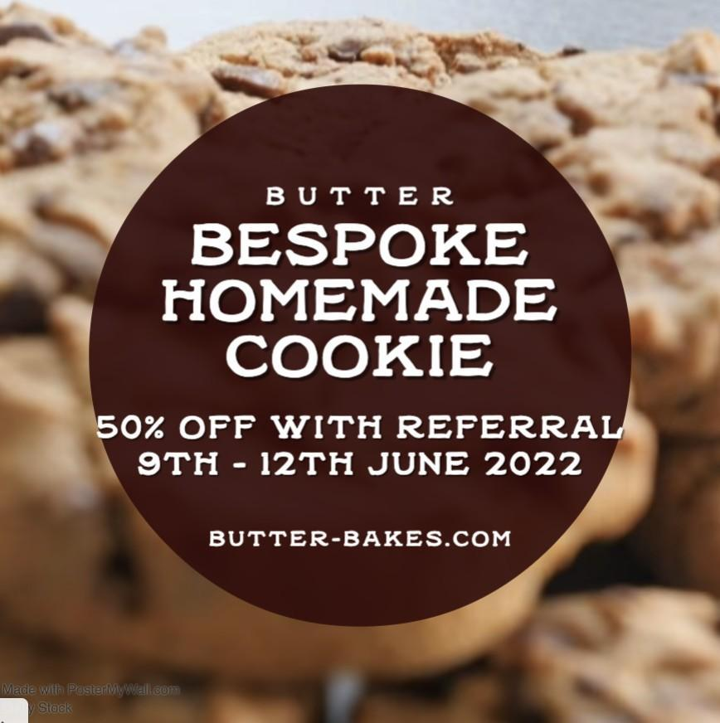

The image below illustrates our monthly objectives of how to make BUTTER become successful as well as compete with alternative competitors from the time BUTTER was launched and making sales to the end of the year to review how BUTTER has adapted to the changes of customers’ preferences and seasonal sales trends over the past year as well as implement marketing strategies accordingly to expand brand awareness while retaining loyal customers. As the annual theme is to go beyond ordinary cookies our team would be proposing three different ways of differentiating Butter from others.

1. Customizable size

 Small - 3 inches (diameter)  Medium - 4 Inches

 Giant - 10 Inches

1. With optional topping

 Rainbow sprinkles  Confetti

 Chocolate  Icing sugar  Raisin

 Cranberries  Almond

 Marshmallows  Diced candy

1. Special Holiday cookie looking

 Christmas Cookie (With M&M cookie)  Gingerbread cookie

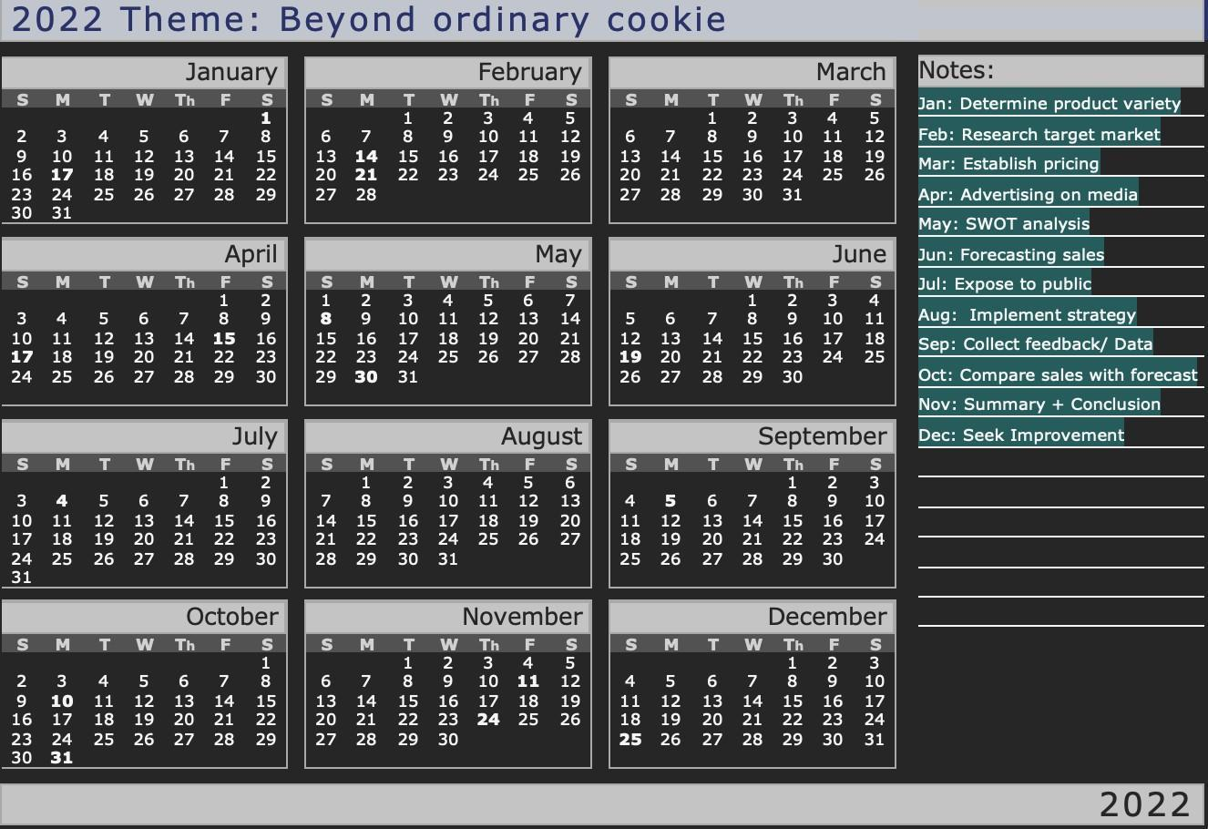

## Personal Selling Plan

As BUTTER is a cottage bakery business therefore most of the business will be conducted in-person by owner to customer selling directly without third-party delivery company and retailer due to lack of licensing. Basically, BUTTER could be sold in several ways to market a bigger potential market by setting up a booth at a food fair where customers could buy the product in which they have tried and personal marketing is the best way to gain product

recognition. Additionally, advertising online or mailing business cards to people ensures the coverage of butter to be spread out rapidly and obtains brand awareness as BUTTERS nurtures its customer. Identifying buyer traits helps BUTTER focus on a certain group of people and rapidly allocate its marketing resources toward that group in order to stimulate the demand for BUTTER effectively.























## Customer Service Plan

In this section we are going to look at what service is going to look like for BUTTER’s customers. Customer service is one of the most crucial parts of running a business. It's the backbone of business because happy customers equal repeat customers. Thus more business. These next few bullet points is discussing how BUTTER should ensure that it is achieving high standards in customer service and experience. Happy customers will give good service ratings with will boost the business's credibility and trustworthiness.

* + Quality Guarantee

All BUTTER products sold will automatically come with a 24 hours quality and taste guarantee. Food must be stored as recommended on the packaging to receive a full refund. As food product is not recyclable thus they won’t be refunded unless disqualified for taste, texture, and condition.

* + On-time delivery

As part of the customer service including delivery and estimated pick-up time whenever Butter is ready to pick up customers would receive either a phone call or text message reminding them. For delivery service, customers should expect their order to be delivered on time to wherever they desire unless unexpected circumstances come up with a solution and compensation plan.

* + Clear ingredient label/policy

Any customer with food allergies would be marked on the order to make sure their order doesn’t contain those ingredients and all the ingredients will be listed on the label or menu on the website accordingly as a disclaimer. Optimally with a nutrition label and estimated calories next to ingredients if possible.

* + Customizable order

Customers with special requests for instance gift packaging service, Vegan cookie, or special order ideally would be acceptable to assure differentiated products and set aside Butter from its competitors. BUTTER concentrates on customer satisfaction which values the needs of the customer and would do as much as possible to fulfill the customer’s desire.

# Pricing Strategy

## Price Competition

In price competition, products are complete substitutes, so companies stay competitive only if the price is lower. In contrast, in non-price competition, brands stand out because of quality, unique selling proposition, competitive advantage, great customer service, etc. Pricing and demand have an extremely important relationship, as an increase in demand typically results in lower demand and vice versa. Demand pricing is the process of calculating price on the basis of the relative demand for the product, as evidenced by the elasticity of demand characteristics of the product. Demand pricing is the most customer-orientated form of pricing since it derives entirely from consumer demand, and Karen Joy can use this concept to display a price that will attract customers but also generate a high-enough profit. In Karen Joy’s market of specialty-based goods, she is most definitely in the nonprice market because her brand is standing out in aspects other than price (taste, quality, customer relationships). Prices in this market vary greatly; the chart illustrates the average price per unit of baked goods in the U.S. in 2016. Looking at BUTTER’s prices, Karen Joy is competing with products that are generally lower-priced than her baked goods (her goods range from $9-$33). However, in the specialty baked goods market pricing is not generally used as a competitive tool. My group’s perceptual maps revealed that Butter is in a market where bakeries set higher prices because of the special quality and uniqueness of the products they sell, whereas run-of-the-mill bakeries like Walmart and Meijer seek high demand with their cheaply priced, pedestrian baked goods. In general, a business that opens with high prices might scare off potential customers, yet Karen Joy has already had a decent amount of sales with BUTTER and even sold out on some items. Thus, her higher price points will indicate high quality and attract customers looking to buy specialty baked goods, as her brand stands out in the taste, quality, and customer relations departments.

## Pricing Decisions

1. Our group’s main marketing objective for BUTTER is to increase brand presence. The high initial price is fine due to some customer awareness already existing and BUTTER’s commitment to excellent customer service with its products.

2. The pricing objective is to generate sufficient cash to cover expenses; then hopefully demand will increase exponentially and lead to profits after establishing a solid customer base.

3. Right now Karen Joy’s fixed costs (licensing, kitchen equipment, utilities, etc.) are relatively low. An increase in sales will more than cover her variable costs such as ingredients, packaging, etc.

4. Karen Joy might devote some money to promoting BUTTER via social media, especially with the upcoming holiday season. She can choose some free advertising methods such as a Facebook post or pay for an ad on a platform like Instagram.

5. Karen Joy is solely responsible for the production of her products so she does not need to consider other retailers in the equation when it comes to pricing (unless she wants to pursue high-quality brand packaging by a third party).

6. Right now, Karen Joy has already had some sales and positive reception for her product, and there are no immediate indications that she has to reduce her current price points.

7. By focusing on producing high-quality products, Karen Joy can effectively undermine her competition’s products at the same time even with her higher-than-average prices.

8. Karen Joy does not need to expend a lot of money because she is already authorized to produce and distribute home-baked goods in her home kitchen in the state of Michigan.

## Marketing/organizational objectives

Our group’s consensus on Karen Joy’s current price point is that it is satisfactory and will fulfill the main objective of increasing brand awareness. Right now, pricing is more of a means of survival as BUTTER is still an extremely new business. The higher price point is necessary to reflect the high quality of her goods and to attain a return on investment in the time, money, and effort it takes for Karen Joy to produce each of her products. This high price will eventually enable BUTTER to increase its market share in the luxury goods market. As stated before, this price point will signal high quality, and with good customer service, the product will speak for itself and start generating significant cash flow.

## Target Market

The target market is willing to pay a higher price for higher quality baked goods, based on the reviews for similar luxury bakeries such as Sandra Kay, Suisse Chalet Bakery, and Sweet Dreams. On Google, all these businesses had multiple dollar signs tacked onto their profile to indicate higher prices, but they all had favorable reviews because customers were extremely satisfied with the value they received when purchasing the baked goods at the high price points.

## Basis for Pricing

We will be using a combination of cost-based pricing and competition-based pricing. Karen Joy explicitly mentioned the high-quality, more expensive ingredients and painstakingly meticulous methods she uses to craft her baked goods. Thus, a higher price needs to reflect this process. However, the competition-based pricing will serve to reign in her prices slightly, and make sure she does not greatly exceed a price point in the specialty baked goods market.

## Final Pricing Strategy

We will consider BUTTER as a newer business because Karen Joy only started marketing her product in June of 2022 and only has definite sales numbers for the month of October. Thus, our group will choose price skimming as the primary pricing strategy choice because as stated before, we want her high price point to reflect the high quality of her specialty goods (and Karen Joy herself stated that lowering her prices to attract more customers would be contrary to the nature of her business). The excellent customer service along with the delicious goods will provide each customer with sufficient value to consider rebuying her products and spreading the word to other potential customers.

## Marketing Budget

The marketing budget for BUTTER is $3000. This might seem like a lot for a cottage business but, one this figure is the upper limit amount, and two, BUTTER has to aim to get recognition in Michigan or at least within a 30-mile radius of where Karen Joy is located. BUTTER would most likely use $2000 of that allocated $3000 from the marketing budget which gives Karen Joy $1000 to use in other departments of the business. In the “Promotion Option” section of this marketing plan, an outline was given on different marketing promotion options that could be used to market BUTTER and the approximate price of each option. BUTTER has a head start when it comes to promotions as it has an up-and-running website, business cards, and a social media page (however this could be improved significantly to promote BUTTER products). So in this sense, money could be saved here. One key area BUTTER could invest in is adding more images of BUTTER products and operations on its social media page or the flyers. This will probably be the most expensive part of the process as semi-professional photographers can cost up to $150 per hour or per picture, but it will be a one-time investment and it will improve the aesthetics of the products. A total of 5 – 7 new images should be taken of the foods BUTTER has to offer and they could go on the website and the social media page. This would come out to a total of $1050 max. The next promotion option BUTTER should invest in is flyers. Flyers cost approximately $0.50 a piece, so printing 1500 flyers will be an investment of 750 dollars. This brings the total spent on marketing thus far to $1800. To save cost Karen Joy could distribute these flyers herself or leave a stack in busier areas where lots of people will come across them. Postage will not be too much of an extra cost and could be advantageous if this is what Karen Joy wants to do instead of the two proposed distribution options. The last promotion option was local newspaper ads. At a rate of $60 for 2 inches of black and white space, BUTTER could invest $60 for holidays such as Easter, Thanksgiving, Christmas, and New Year to get the word out at those peak seasons. This brings the total for the marketing budget to $2040. This leaves $960 to invest in other areas of the business or even for the minimal maintenance fees mentioned for each promotion option discusses in the “Promotion Option” section of this marketing plan. BUTTER should account for the packaging cost for each product also. This could be $1 approx. per folding carton.

## Implementation Plan

BUTTER will set SMART goals. These are goals that are Specific, Measurable, Attainable, Relevant, and Time-based. Additionally, goals will be based on BUTTER’s SWAT analysis for maximum marketing outcomes. Below is a table of goals BUTTER should have, how these goals are SMART goals, and the deadlines for these goals.

| S.M.A.R.T. Goal | Deadline/time-frame |
| --- | --- |
| S: Deliver orders within max 1 business day from the day of customer order.  M: Must be a 1-day window from the order date to the delivery date.  A: Previously completing an order within 24 hours was attainable. BUTTER should look to cut that time to 12 hours if possible.  R: Customers want things as soon as they can get them. Today, delivery times can be the deciding factor between customers' end decisions on who to buy from.  T: BUTTER should aim to reach this goal within the first two weeks of beginning/resuming operations. | 2 weeks before the start of business operations. |
| S: Flyers and Newspaper ads should be designed and ready to distribute 3 weeks before each major holiday mentioned in the previous section.  M: 1500 flyers should be printed for distribution.  A: Flyers are relatively simple to design and produce and at a lost cost.  R: Flyers with the designed right are eye-catching and work. People read newspapers and glance at flyers even if it is considered irrelevant to them.  T: Distribution should take place no less than 2 weeks from the major holiday. | 2 weeks before each major holiday |
| S: BUTTER will create its own social media page that is separate from Handsewn.  M: Preferably 2 social media accounts, one on Facebook and the other on Instagram will be opened in one week.  A: Social media pages are quick and simple to create. And it’s free.  R: social media is a great way to reach both the older and current generations. Almost everyone today has a social media account.  T: 1 week from the start of operations. | The deadline for this should be no later than 2 weeks from the start of business operations. |
| S: Upload 5 – 7 pictures of BUTTER products on the social media pages.  M: 5 -7 images starting off.  A: A good photographer should have no problem taking some great shots of BUTTER’s delicious, freshly made foods.  R: An active social media page shows that a business is currently operating and engaging.  T: This should be done no more than 3 days after the business opens as this will add to the customer experience and the ecosystem BUTTER seeks to build. | Deadline 1 week after operations start. |
| S: Have 7 - 9 sales per month and at peak season 10 – 12 sales.  M: This target is a good place to start as demand for desserts tends to be lesser in off-peak times but higher during major holidays.  A: Karen Joy has the resources and funds to fulfill these orders as long as they are spread out during the month.  R: As mentioned dessert sales are higher during the holiday seasons so making more desserts only makes sense to meet the needs of more customers.  T: Monthly goal | The deadline for this quota is every month. |

## Growth Plan and Strategies for Market Penetration

Growth for BUTTER is promising. BUTTER offers unique products backed by quality and taste. BUTTER is reasonably priced and has a good range of products to choose from. As the organization grows, it has the option of increasing the number of products it offers on its menu or it can also choose to deliver further away from its home base thus increasing its reach as a competitive business. The current marketing budget is applied for the next year, with a savings of $960 approx. BUTTER could invest in better marketing and delivery options to expand the business. This ties in with market penetration as BUTTER at that point will be reaching more potential customers and clients. BUTTER does not need a diversification strategy because that would take away from the “uniqueness” of BUTTER just like how Bentley should not start making budget family cars. It's unnecessary at BUTTER’s current state. Also, diversification can be limited without a commercial kitchen license.

## Evaluation and Control

In this section, we will be looking at Key Performance Indicators for BUTTER. Key Performance Indicators look at what key metrics BUTTER will track to help determine how effective the marketing strategy is.

KPIs:

* Orders per month - BUTTER will be keeping track of the number of orders per month. With this information, the business will be better prepared for higher demands for BUTTER products in seasons that show higher orders.
* Client retention rate – This metric will be used to keep track of how many customers are repeat customers. With this information, BUTTER will be able to determine ways to retain customers as well as add more customers based on what’s working/or appealing to the return customers.
* Profit margin – Information on profit margins is key to a business because it allows managers to see how much the business is making in profits compared to how much it is spending. Promotions and discounts could be used to boost sales and thus profit margins.
* Social media engagement – The metric asks the question of if our social media engages with our customers. Is it helping bring more customers in and keeping them in the loop? The aim is to generate a following and a community around the business which adds credibility to the business. Replying to comments and keeping up to date with trends and uploading product images could increase engagement on social media pages.
* Customer satisfaction – is BUTTER catering to the needs and expectations of its customers? This Metric is one of the most important because with this information the business will be able to develop its products and operations using improvements and feedback from the customers themselves. If customer satisfaction is low BUTTER should aim to act on the feedback from customers in a reasonable and viable manner to fulfill their needs and boost customer satisfaction.
* Revenues and Expenses - BUTTER must monitor its revenue and expenses to see where it can gain more revenues and where it can reduce expenses while still maintaining high quality.

## Recommendation and Priorities for BUTTER

BUTTER is positioned well right now in the market and in a physical location because of a number of factors. One factor is that there aren’t too many competitors in the Berrien Springs and Benton Harbour areas. Thus it will be easier for customers to choose BUTTER to buy from. It has great potential to grow in the future. One recommendation and priority for BUTTER is raising awareness of the business, especially because it isn’t a well know business just yet. The promotion option mentioned earlier are a few avenues to do this that can be very effective and are reasonably priced but, Karen Joy does not have to stick with these specific methods exactly. With a higher awareness of the business comes more potential customers, more sales, and more recommendations through customer reviews and word-of-mouth recommendations. Another recommendation could be designing a menu based on/around specific holidays in the year. BUTTER can capitalize on this and get more sales during these times. The highest priority for any for-profit business is making money. BUTTER has to monitor its profit margin and work to make operations more efficient to save costs. Another recommendation for BUTTER should be adding more to BUTTER’s social media page in terms of videos and pictures of the products. This will add credibility to the business and make the business more attractive to potential customers. Creating a media post calendar for the month each month can structure your posts into regular impactful posts.

## Appendices

